PANCASILA: A CULTURAL FILTER AMONG YOUTH IN FACING GLOBALIZATION

Course: Pancasila Education
Lecturer: Taufiqurrahman, M.Pd



Prepared by:
Group II (Computer Science 1.D)
Muhammad Fachril (Leader) – B0225145
Nia Ramadhani – B0225183
Nabilla Suraya – B0225162
Qusnul Fatimah – B0225184
Fitrah – B0225152
Sudirman – B0225153
Muhammad Alfayed – B0225172

FACULTY OF ENGINEERING AND COMPUTER SCIENCE
COMPUTER SCIENCE STUDY PROGRAM
MUHAMMADIYAH UNIVERSITY OF BIMA
ACADEMIC YEAR 2025/2026

FOREWORD

All praise is due to Almighty God, for by His grace and blessings this paper has been completed properly and on time. This paper was prepared as an assignment for the Indonesian Language course with the theme of gender perspectives in the use of the Indonesian language. It is hoped that this paper will provide useful insight and understanding for readers.

The preparation of this paper aims to broaden knowledge and present a comprehensive overview of gender perspectives in the use of the Indonesian language. Hopefully, this paper will be beneficial to readers and expand their understanding. The material presented has been compiled from relevant and reliable sources.

The author realizes that this paper is far from perfect; therefore, constructive criticism and suggestions are greatly appreciated for future improvement. Sincere gratitude is extended to all parties who contributed to the completion of this paper. May this paper be useful and serve as a valuable reference.

Bima City, October 3, 2025

CHAPTER I
INTRODUCTION

  - Background
We live in a borderless era. Globalization brings a powerful flow of foreign information and culture through digital media, which poses the greatest challenge for today’s youth due to the massive speed of change. Adolescents, as the most active users of technology, become the main targets of value transformation. Problems arise when incoming foreign cultures are not aligned with national identity. Therefore, Pancasila must be positioned as a “shield” or filter to screen external influences so that youth do not lose their direction.

  - Problem Formulation

- What are the entry points of foreign culture into the minds of youth?
- How do the values of each principle of Pancasila function as a cultural filter?
- What practical solutions can strengthen the internalization of Pancasila in the digital era?

1.3. Objectives
The objectives of this paper are:
- To identify the entry points of foreign culture into youth.
- To understand how Pancasila values act as a cultural filter.
- To determine practical solutions for strengthening Pancasila internalization in the digital era.

CHAPTER II
RESEARCH METHODS

This study uses a quantitative descriptive approach through surveys of youth groups. Respondent data are as follows:
Group 1 (53.3%): 16 individuals (9 males, 7 females) aged 15–21 years.
Group 2 (46.7%): 14 individuals (6 males, 8 females) aged 15–21 years.
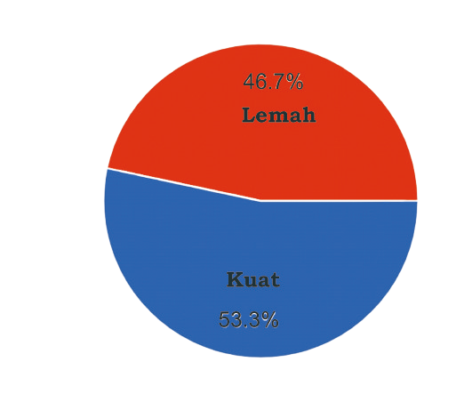

Data were analyzed to examine the effectiveness of Pancasila value internalization through family and digital approaches.
Strong Category (73.3% ≈ 22 individuals)
Gender: Male (12), Female (10)
Age:
15 years: 7 individuals
16–18 years: 10 individuals
19–21 years: 5 individuals

Weak Category (26.7% ≈ 8 individuals)

Gender: Male (3), Female (5)
Age:
15 years: 4 individuals
16–18 years: 3 individuals
19–21 years: 1 individual

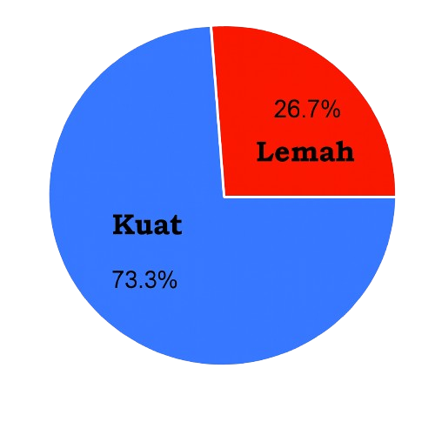

CHAPTER III
RESULTS AND DISCUSSION

2.1 Analysis of Foreign Cultural Entry Points in the Digital Era

Based on research data, 100% of respondents own smartphones connected to the internet for more than 8 hours per day. Smartphones are no longer just communication tools but the primary gateway for foreign cultural influence.
Social Media (TikTok, Instagram, YouTube): Youth are exposed to global lifestyles and hedonistic trends through algorithms.
Online Games: These platforms introduce unhealthy competition and declining politeness.
Pop Culture Hegemony: The dominance of foreign culture causes youth to be more familiar with other nations’ cultures than their own.
Survey results indicate that 60% of respondents are strongly influenced by social media, while 40% experience a shift toward individualism.
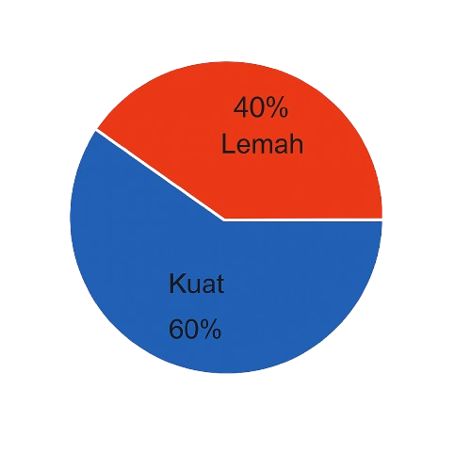

2.2. Pancasila as a Cultural Filter
Pancasila does not function passively; rather, it operates as a value system that filters global influences through several layers of regulation:
- Moral Filter (Principles 1 & 2): This filter functions as a subconscious ethical alarm. When adolescents are exposed to content that exploits violence or pornography, the principles of Belief in God and Just and Civilized Humanity generate a moral rejection based on ethical and religious standards upheld in Indonesia.
- Rational Filter (Principle 4): Amid the overwhelming spread of misinformation (hoaxes) and digital provocation, the fourth principle encourages adolescents to develop critical reasoning. The principle of deliberative wisdom requires individuals not to accept information uncritically, but to verify and reflect collectively before disseminating it.
- Identity and Social Filter (Principles 3 & 5): The third principle ensures that even as global technologies are adopted, national identity remains distinctly Indonesian. Meanwhile, the fifth principle regulates the consumptive tendencies of globalization by teaching adolescents to value social balance and reject extravagant lifestyles that merely emphasize personal social status.
2.3. Strategic Measures: Synergy Between Family and Digital Transformation
To strengthen the position of Pancasila among adolescents, practical solutions are required that are not doctrinal in nature but adaptive to contemporary realities:
- Transformation of the Family’s Role: The family should function as a “Pancasila Laboratory.” Rather than merely restricting gadget use, parents are encouraged to apply Pancasila-based case studies through informal discussions on current issues—such as corruption or social injustice—during family interactions. Establishing household rules through deliberation (Principle 4) also trains adolescents to respect differing opinions and legitimate authority in a civilized manner.
- Value-Based Digital Literacy: Addressing challenges in the digital sphere should not involve disconnecting from the internet, but rather strengthening digital literacy. Adolescents need to be educated in cyber etiquette rooted in the second principle (Just and Civilized Humanity) to foster an online environment free from cyberbullying.
- Technology Utilization (Gaming for Good): Integrating values of honesty and sportsmanship (Principle 5) within online gaming communities. Young people are encouraged to create creative digital content that promotes Indonesia’s cultural richness, enabling digitalization to serve as a medium for disseminating Pancasila values at the international level.

CHAPTER IV
CONCLUSION AND SUGGESTIONS

3.1. Conclusion
Pancasila is not merely a set of principles to be memorized for examinations, but a global navigational framework. The responsibility of the younger generation is not to isolate itself from the outside world, but to critically adapt and filter external influences so that they remain aligned with Indonesia’s noble national character.
Let us adopt Pancasila as a personal code of ethics wherever we are, both in the physical world and in the digital sphere. With Pancasila as a guiding shield, we can become a generation capable of embracing global progress without losing our identity as the Indonesian nation.

3.2 Suggestions
Youth should apply Pancasila as a personal ethical code in digital life, and parents should actively foster value-based discussions at home.

REFERENCES

Asmaroini, A. P. (2016). Implementation of Pancasila Values for Students in the Globalization Era. Jurnal Moral Kemasyarakatan, 1(1), 30–46.
Nurizka, R., & Rahim, A. (2020). Internalization of Pancasila Values through Digital Media. Journal of Civic Education, 8(2).
Surono. (2016). Pancasila as a Filter of Globalization. Jurnal Sosio-Religi, 14(1).
Kaelan. (2014). Pancasila Education. Yogyakarta: Paradigma.

